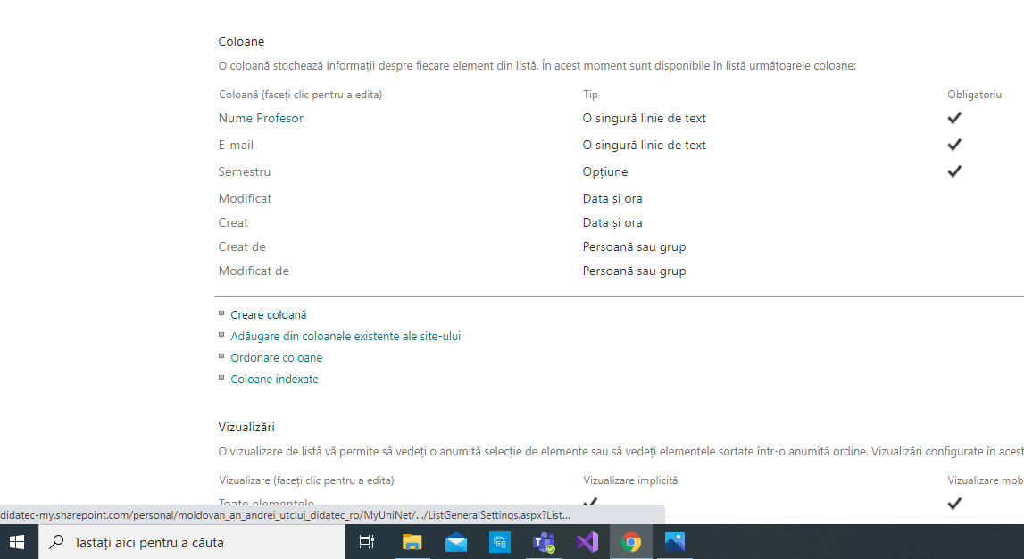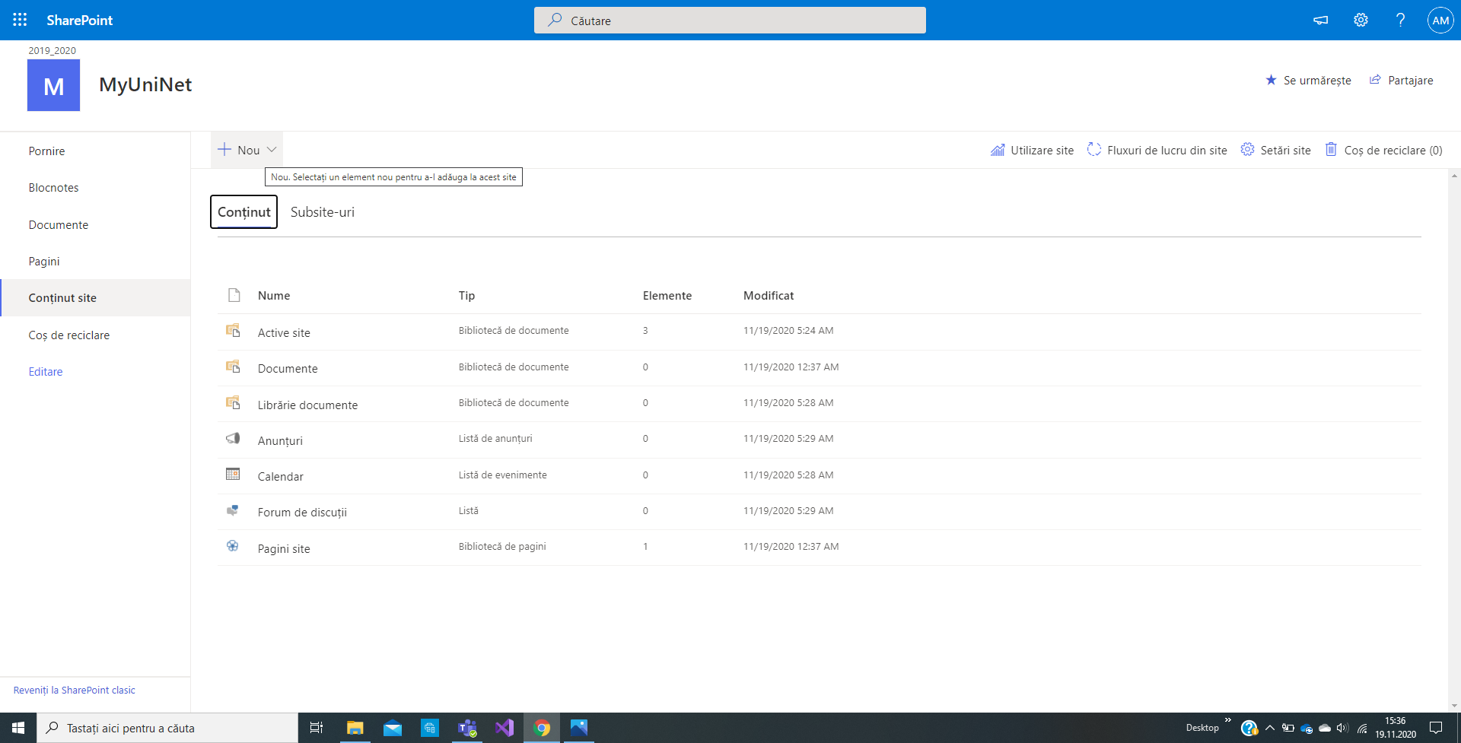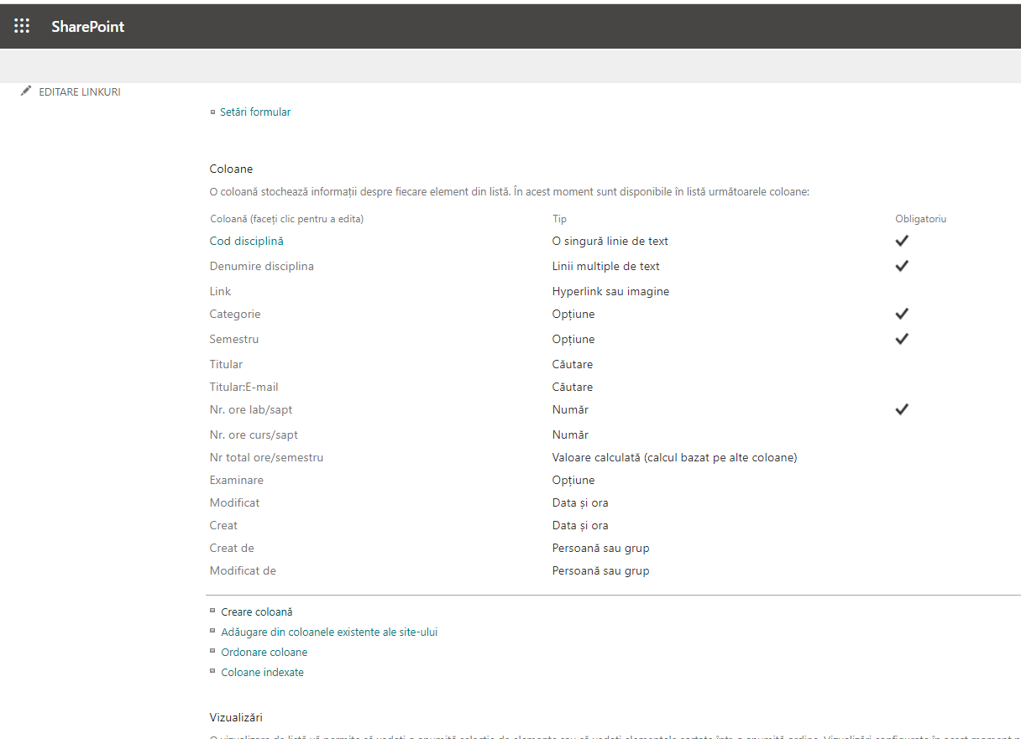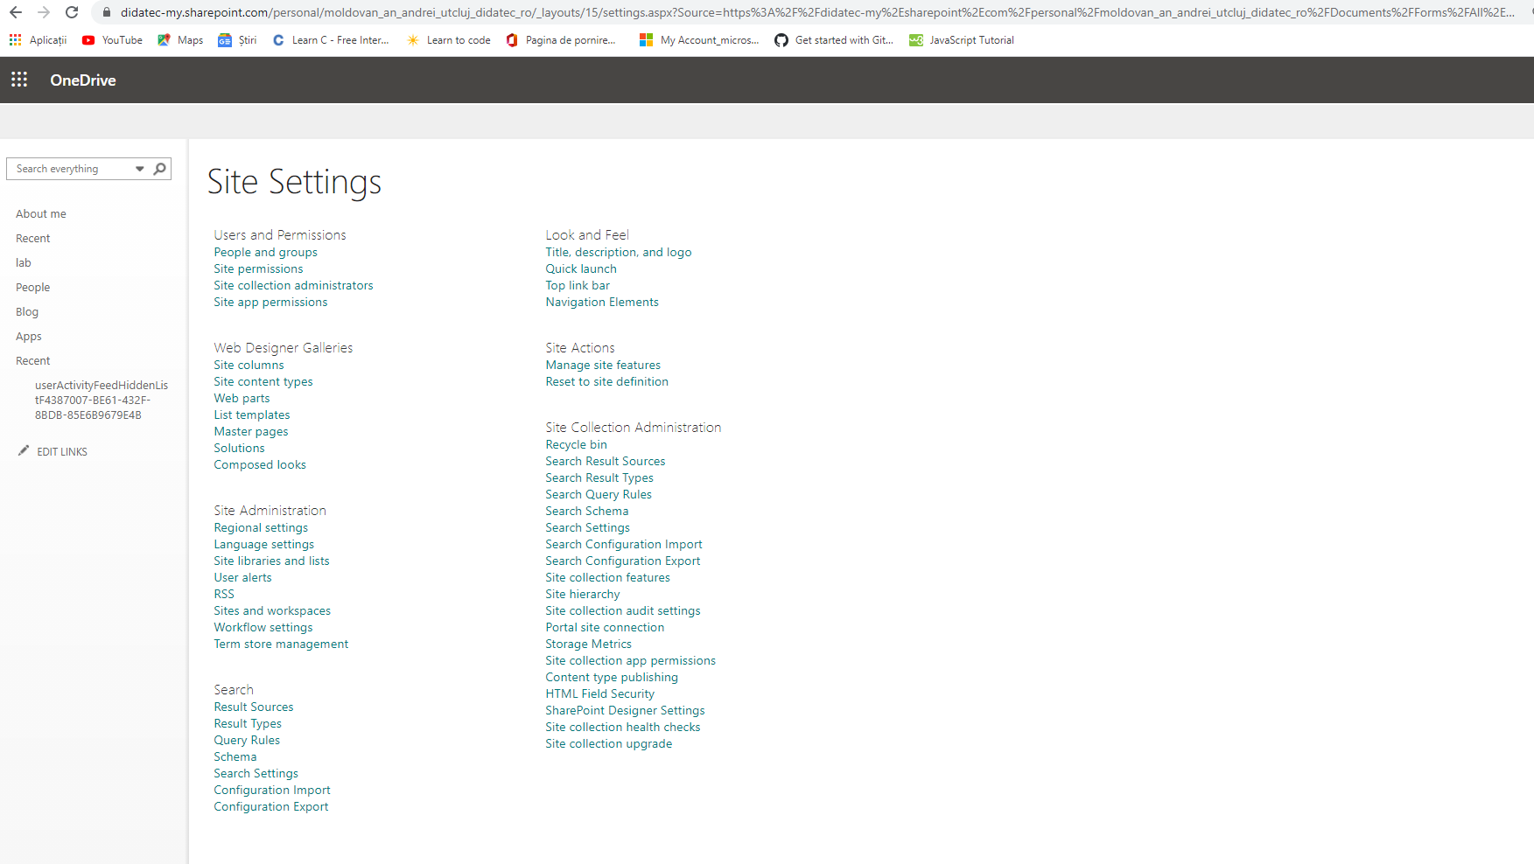

<https://didatec-my.sharepoint.com/personal/moldovan_an_andrei_utcluj_didatec_ro/MyUniNet/SitePages/Home.aspx>

<https://didatec-my.sharepoint.com/personal/moldovan_an_andrei_utcluj_didatec_ro/MyUniNet/2019_2020/SitePages/Home.aspx>